Drive Mappings and FileZilla:
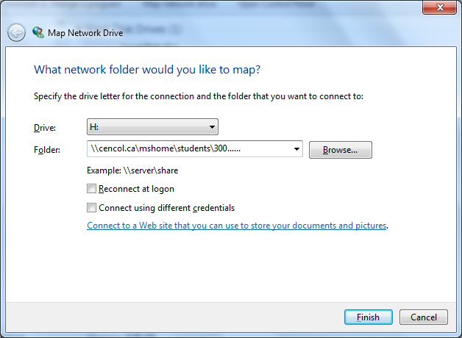
P drive mapping:
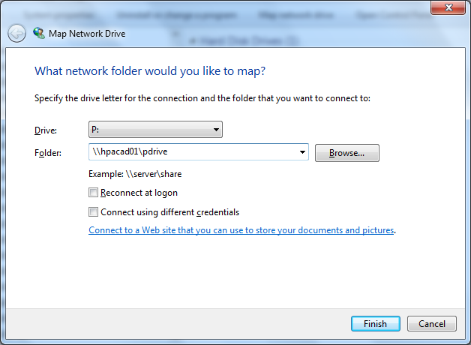
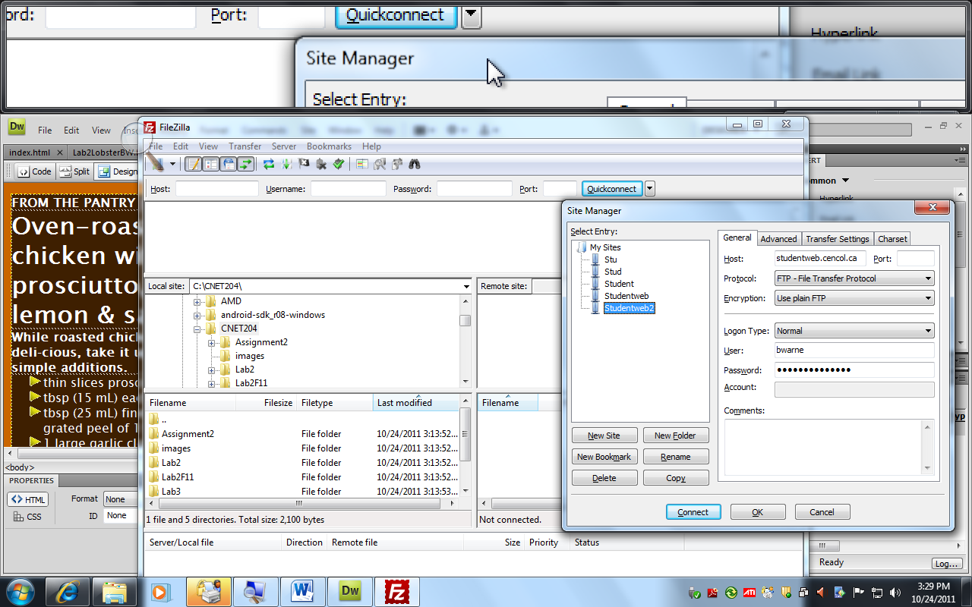
Put your student number here and the password you use to login to your student account at the college and click [Ok] not [Connect] Then click the down arrow in the toolbar to select the studentweb connection
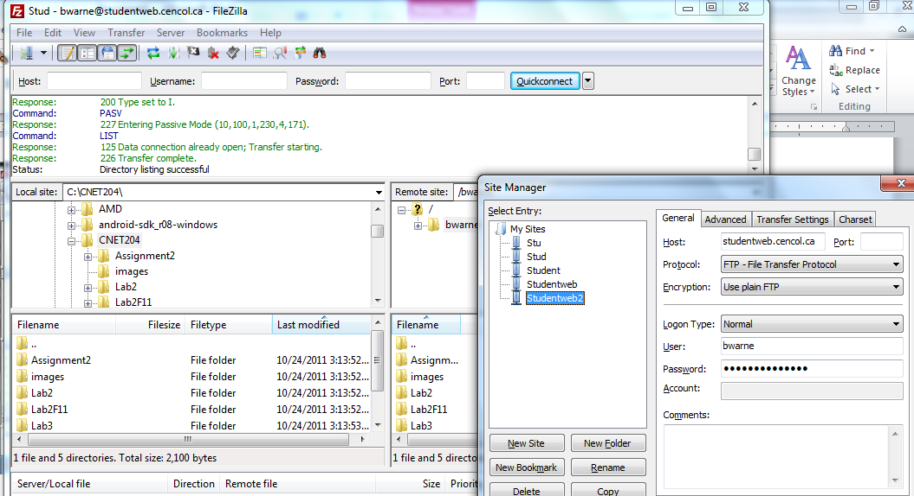
Navigate to H:\CNET204 and select all files and folders you want to upload to the studentweb webserver this is the local site. All you do is drag what you want to be made available to the internet community to the remote site on the right hand side of the FileZilla window. Make sure you do not drag the root folder CNET204 to the remote site. Only drag files and folders inside the CNET204 folder to the remote site for viewing in the browser. Always test your work by viewing the pages through the http protocol [ http://studentweb.cencol.ca/???????? replacing the question marks with the characters preceeding the @ sign in you’re my.centennial email address

